**Lesson 5 Demo 11**

**Managing Resources for Workloads**



Steps to be followed:

1. Defining multiple resources in a single configuration file

**Step 1: Defining multiple resources in a single configuration file**

1. Create a config file with the following command:

***vi multiresources.yaml***



1. Write the following code in the file:

***apiVersion: v1***

***kind: Service***

***metadata:***

***name: mysvc***

***labels:***

***app: nginx***

***spec:***

***type: LoadBalancer***

***ports:***

***- port: 80***

***selector:***

***app: nginx***

***---***

***apiVersion: apps/v1***

***kind: Deployment***

***metadata:***

***name: mydep***

***labels:***

***app: nginx***

***spec:***

***replicas: 3***

***selector:***

***matchLabels:***

***app: nginx***

***template:***

***metadata:***

***labels:***

***app: nginx***

***spec:***

***containers:***

***- name: nginx***

***image: nginx***

***ports:***

***- containerPort: 80***

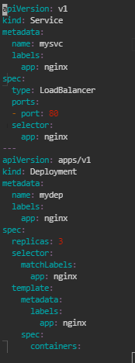

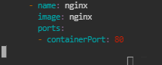

1. Write the following command to create the resource:

***kubectl apply -f multiresources.yaml***



1. Write the following command to check the list:

***kubectl get all***

